**LAB 4 CHECKOUT: ACTIVE BANDPASS FILTER PROJECT**

**ELEC 3509A - L6**

**Name:** Youssef Ibrahim

**Student #:** 101103080

$$X=101103080$$

$$A=X mod 1031=127$$

$$B=X mod 1033=271$$

* **Lower Cut-off Frequency**
$$f_{-3dB Lower}=\frac{A^{5}}{5.534*{10}^{9}}-\frac{A^{4}}{2.11*{10}^{6}}+\frac{A^{3}}{2287}-\frac{A^{2}}{6.1}+20.2A+750=1449.64 Hz$$

$$δ=-\frac{B^{2}}{180000}+\frac{B}{173}+0.5=1.66$$

* **Upper Cut-off Frequency**
$$f_{-3dB Upper}=f_{-3dB Lower}\left(1+δ\right)=3856.04 Hz$$

* **First Stage $H_{A}\left(S\right)$** 
  + **Simulation using Theoritical Values**

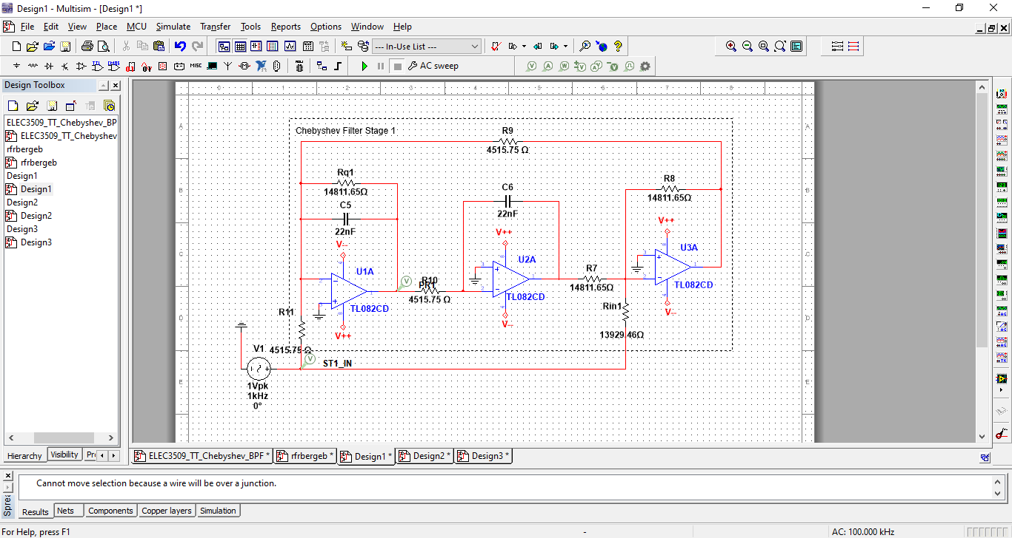

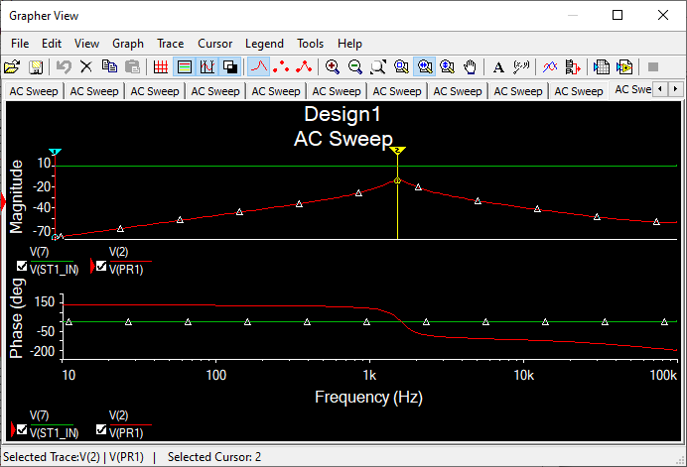

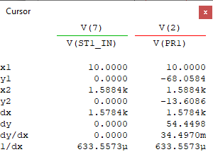

Center frequency is at 1588.4 Hz (9980.2rad/s), and Gain is -13.6086 dB.

* + **Simulation using Standard Values**

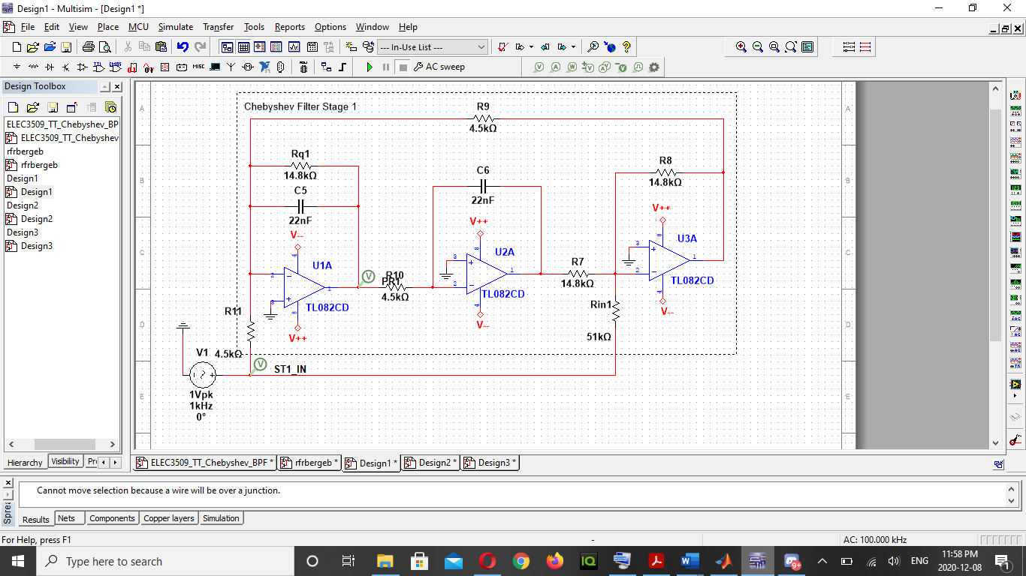

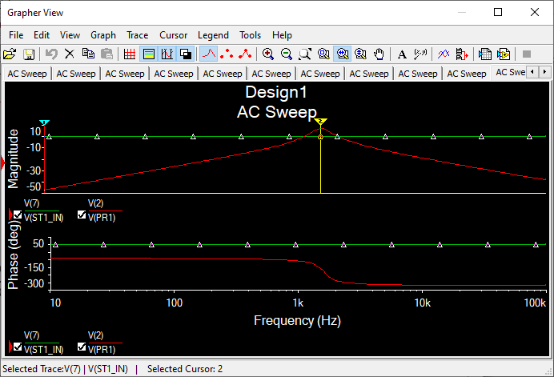

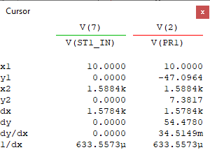

Center frequency is at 1588.4 Hz (9980.2 rad/s), and Gain is 7.3817 dB.

* **Second Stage $H_{B}\left(S\right)$** 
  + **Simulation using Theoritical Values**

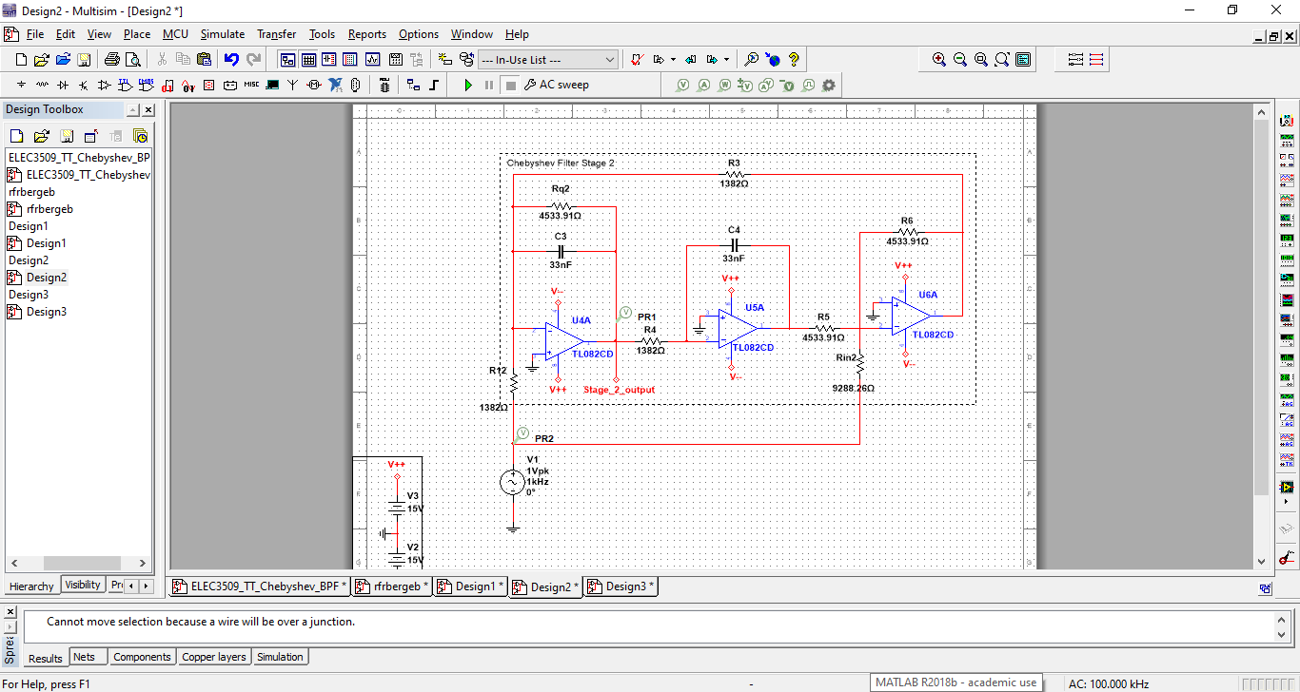

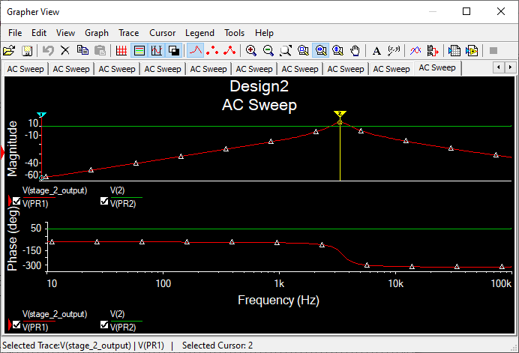

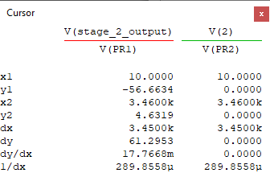

Center frequency is at 3460 Hz (21739.8 rad/s), and Gain is 4.6319 dB.

* + **Simulation using Standard Values**

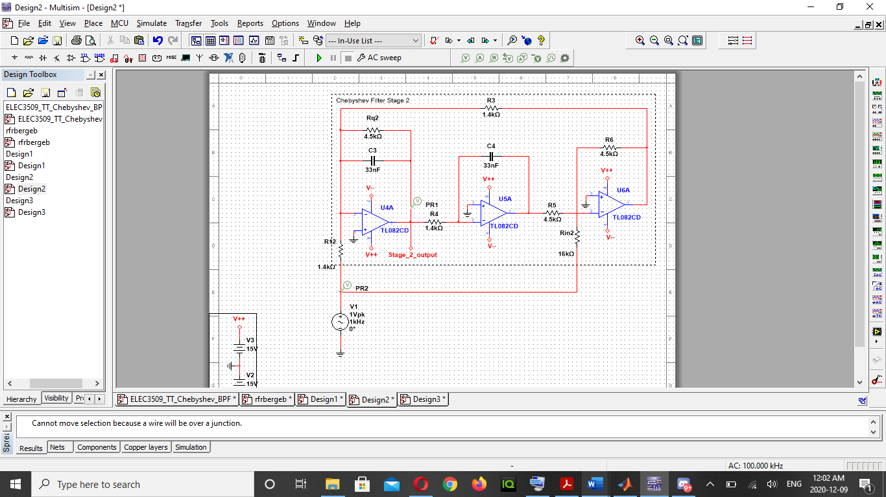

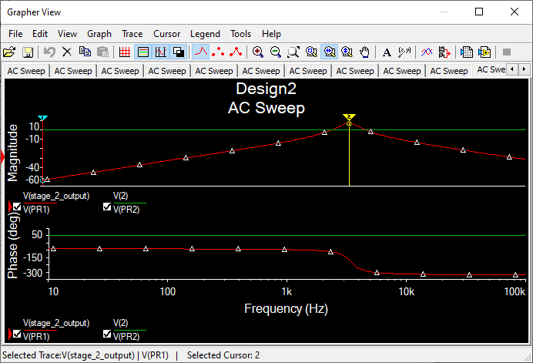

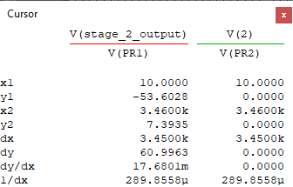

Center frequency is at 3460 Hz (21739.8 rad/s), and Gain is 7.3935 dB.

* **Full Chebyshev Filter $H_{4}\left(S\right)$** 
  + **Simulation using Theoritical Values**

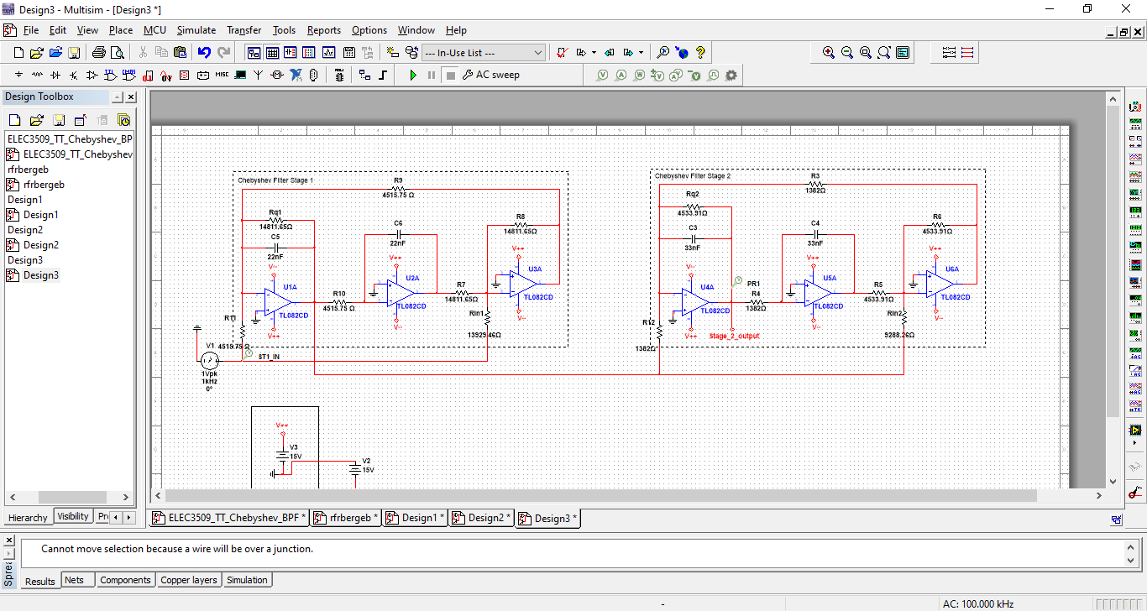

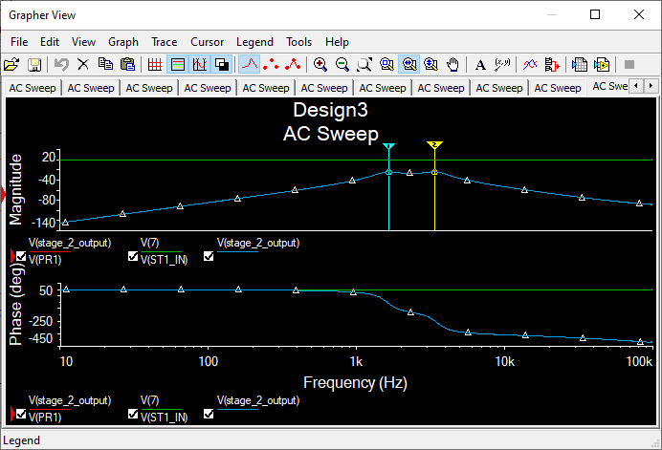

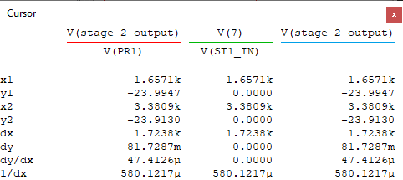

The Full Chebyshev filter has a lower -3db frequency equals to 1657.1 Hz (10411.8 rad/s), and upper -3dB frequency equals to 3380.9 Hz (21242.8 rad/s).

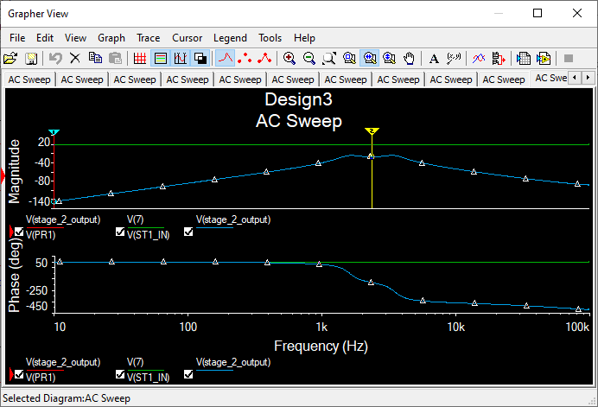

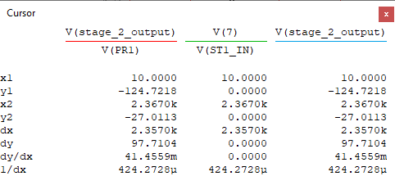

The Full Chebyshev filter has a gain of -27.0113 dB and center frequency equal to 2367 Hz (14872.3).

* + **Simulation using Standard Values**

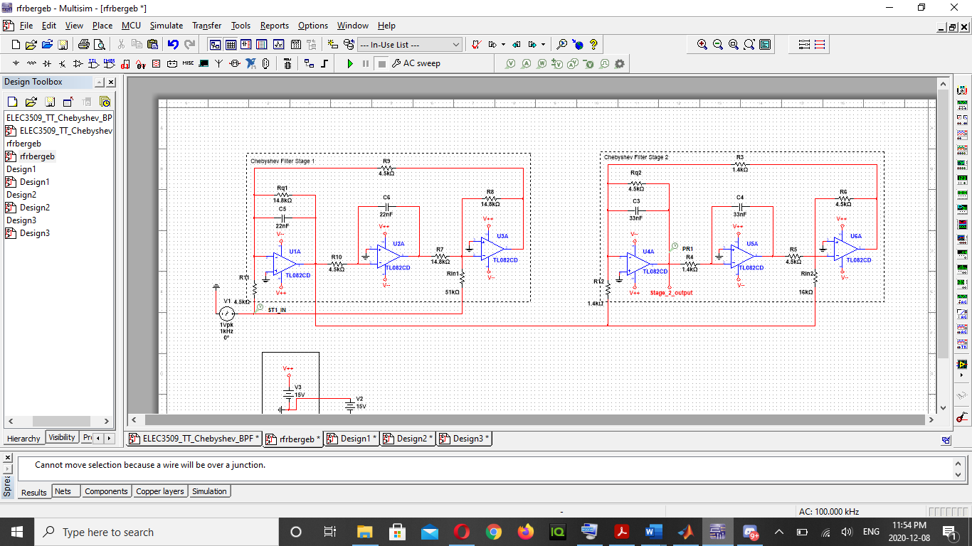

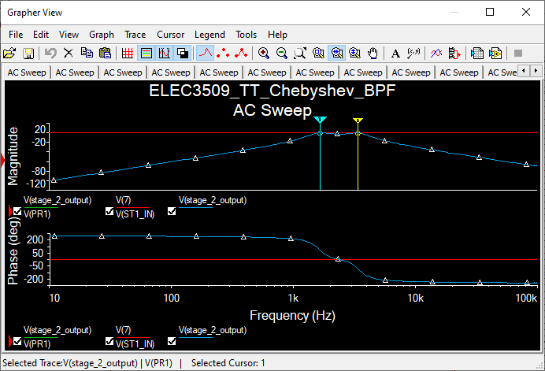

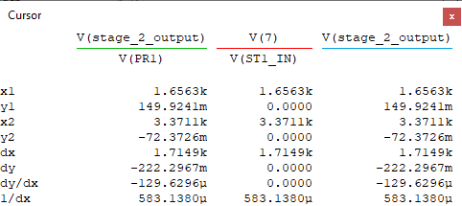

The Full Chebyshev filter has a lower -3db frequency equals to 1656.3 Hz (10406.8 rad/s), and upper -3dB frequency equals to 3371.1 Hz (21181.2 rad/s).

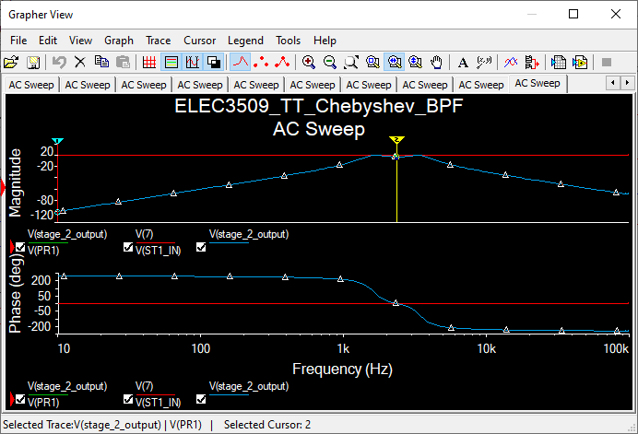

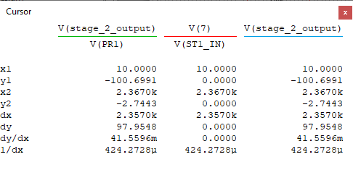

The Full Chebyshev filter has a gain of -2.7443 dB and center frequency equal to 2367 Hz (14872.3 rad/s).

The table below show the theoretical and standard values for the different resistors used in the simulation.